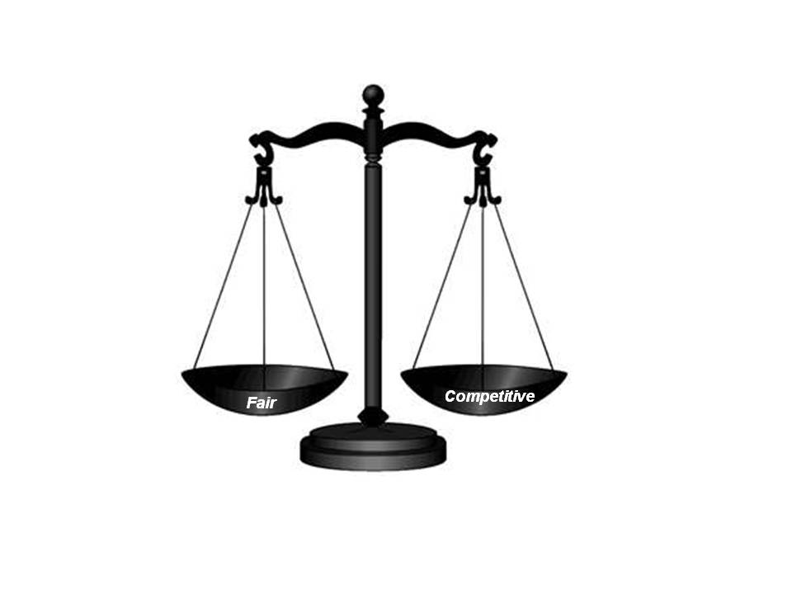

Version: 2.0

August, 26 2013

Version # | Name of Revisor | Revision Description | Date
1.0 | Clinton Parsons Jr | Initial Version | 06/17/2013
2.0 | Clinton Parsons Jr | Updates to increase board from 5 to 7 and redistribution of duties | 08/26/2013
The first number is for major revisions and the second number is for clarifications or minor wording changes.

Article # | Article Name | Page(s)

1 Organization 3 - 4

2 Dedication of Assets 5

3 Membership 6

4 Membership Meetings 7

5 Elections 8 - 9

6 Board Member Duties 10 – 13

7 Removal from Position 14

8 Amendments 15

9 Acknowledgement Statement & Signature 16

10 Board Member Approval Signatures 17

Article 1 | Organization

- This organization shall be known as the Brimfield Athletic Association.

- The principle office of the Brimfield Athletic Association shall be in Brimfield, Ohio.

- The purpose of the organization shall be to encourage youth development by providing opportunities for personal and athletic growth. The B.A.A. promotes sportsmanship, self-esteem, and the development of life skills through engaging youth in sports while providing a safe, healthy, positive environment where the youth of our community can learn the fundamentals of sports.

- The Brimfield Athletic Association will maintain a website that will allow the community to access information on Baseball, Softball, Basketball, Brimfield Athletic Association Board Members and Commissioners.

- The organization’s President shall appoint the Baseball, Softball and Travel Ball Commissioners on a yearly basis at the January meeting.

- The Brimfield Athletic Association shall be the sponsor and sole governing body for youths in the Field Local School District for basketball and for the youths in Brimfield Township for baseball, softball and tee ball.

- The Brimfield Athletic Association board members will be called on to hear and decide by majority vote any and all issues or disputes.

- The organization’s President shall appoint the Basketball Commissioner on a yearly basis at the September meeting.

- The Commissioners, President or designee must represent teams at all Portage Association for Baseball, Portage Association for Softball and Portage Association for Basketball meetings.

- Baseball, Softball, Tee Ball and Basketball players’ eligibility will be handled in the following manner.

  - An official registration form has to be filled out and submitted to a Commissioner or a Brimfield Athletic Association Board Member.

  - The entire registration amount has been paid in full no later than 7 days after the last official sign up date.

  - Players are eligible to play even if they miss the last official signup date. A parent or guardian needs to contact a Commissioner or a Brimfield Athletic Association Board Member to fill out an official registration form.

    - Missing the last official signup date will result in a ten dollar ($10) late signup fee per player due at time of the late signup.

Article 2 | Dedication of Assets

- The properties and assets of this nonprofit organization are irrevocably dedicated to youth sports purposes. No part of the net earnings, properties, or assets of this organization, on dissolution or otherwise, shall inure to the benefit of any private person, individual, Commissioner, or Board Member of the Brimfield Athletic Association.

- Upon the dissolution of the Brimfield Athletic Association, the board members shall, after paying or making provision for the payments of all of the liabilities of the Brimfield Athletic Association, dispose of all of the assets of the organization to one or more organizations organized exclusively for youth sports, charitable, scientific, or educational purposes as shall at the time qualify as exempt organizations under Internal Revenue Code Section 501 (c) (3) (or the corresponding provision of any future United States Internal Revenue Law), as the membership shall determine.

Article 3 | Membership

- To be a Member you must remain in good standing.

  - Must be paid up on dues / youth participation fee.

  - Attend fifty percent (50%) of calendar years meetings.

  - Miss no more than two (2) consecutive meetings without proper cause.

  - Notification of missing meetings must be submitted to the Brimfield Athletic Association Board members for determination of proper cause twenty-four (24) hours prior to the meeting.

- There are six (6) levels of membership.

  - Brimfield Athletic Association Board Members

  - Commissioners

  - Coaches

  - Parents

  - Players

Article 4 | Membership Meetings

- Meetings are the first (1st) Monday of every month starting at 8:00 PM ET.

- Meeting exception, if the first Monday is a holiday then the second Monday will be the meeting day.

- Time exception, during the Baseball and Softball regular season the start time will be 9:00 PM ET.

- All agenda items need to be submitted to the Secretary forty-eight (48) hours prior to the next meeting. An agenda will be created based on the obtained information and handed out at the meeting for discussion.

- All accounting items need to be submitted to the Treasurer seventy-two (72) hours prior to the next meeting, if they are to be discussed. An accounting sheet will be created with the current fiscal situation of the Brimfield Athletic Association and handed out at the meeting for discussion.

- The meeting will be called to order.

- Last month’s meeting minutes will be looked over and approved.

- Accounting sheet will be discussed then approved.

- Discussion on agenda.

- Bring up any new business.

- Take questions from the assembled membership.

- Adjourn meeting.

Article 5 | Elections

- The seven (7) member Brimfield Athletic Association Board will consist of a President, Vice-President, Secretary, Treasurer, Equipment/Apparel Manager, Grounds Keeper and Foreman.

- All voting members and members seeking a board member position must be in good standing in the community and attend at least fifty percent (75%) of all regularly scheduled meetings with in the election calendar year not counting the election meeting.

- Nominations for all positions will be at the August meeting.

  - In the following order members in good standing will nominate themselves or others for the following: President, Vice-President, Secretary, Treasurer, Equipment/Apparel Manager, Grounds Keeper and Foreman.

- The seven (7) member Brimfield Athletic Association Board will be elected by popular vote of members present at the September meeting.

  - Going one (1) board member position at a time after all nominations for that given position are heard the sitting President will call for a vote of hands. The majority vote getter will be declared the winner.

  - Elected board members will serve a two (2) year term beginning at the September meeting.

- Members of the Brimfield Athletic Association Board, who miss three (3) consecutive scheduled meetings without proper cause, shall be removed from office by the membership. First consideration to fill that position will be given to sitting board members. The remaining board members and commissioners will vote if more than one (1) candidate is available otherwise the President will declare the position change.

  - With the open board position members in good standing can nominate themselves for the open position or be nominated by another member in good standing.

  - At the following meeting the open Brimfield Athletic Association Board member position will be elected by popular vote of members present.

  - The newly elected board member will fill vacated position for the remaining term.

- If a Brimfield Athletic Association Board member resigns their position prior to the term expiration first consideration to fill that position will be given to sitting board members. The remaining board members and commissioners will vote if more than one (1) candidate is available otherwise the President will declare the position change.

  - With the open board position members in good standing can nominate themselves for the open position or be nominated by another member in good standing.

  - At the following meeting the open Brimfield Athletic Association Board member position will be elected by popular vote of members present.

  - The newly elected board member will fill vacated position for the remaining term.

Article 6 | Board Member Duties

- President

a. Preside at all meetings.

- Supervise the affairs and activities of the association.

- Enforce the By-Laws of the association.

- Appoint members to fill all positions not elected.

- Appoint an audit committee for an internal audit review in January, but prior to the November meeting.

- To directly oversee sponsorship donations for baseball, softball, and basketball.

- To directly oversee the ordering and placement of all purchased sponsorship signs.

- To directly oversee any interactions with the school board/school officials on changes to the grounds, renting of facilities, billing, and any other correspondence.

- Maintain order during all membership meetings and sponsored activities/events.

- To directly oversee the scheduling of team pictures for baseball, softball, tee ball and basketball.

- Secondary executive of association finances and accounts.

- Co-sign all checks over $500 per vendor.

- Vice-President

  - To aid the President and in the absence of the President, assume all duties associated with the position.

  - To directly oversee the operation of concessions.

  - Responsible for all concession stand appliances/equipment.

  - To directly oversee the operation and maintenance of the official website.

- Secretary

  - Keep records of correspondence of the association.

  - Provide accurate minutes for all membership meetings.

  - Keep records of membership registration forms.

  - Amend By-Laws as noted and approved by the board and membership.

  - Maintain all guides and documents as approved by the board and membership.

  - Maintain the equipment records and equipment sign out sheets.

  - Record and maintain information for all baseball, softball, tee ball and basketball sign ups. All signup forms should flow through the commissioners if not directly received.

  - Record and maintain all correspondence with all Government Agencies, Bureaus or any other persons or groups.

  - Create Agenda for meetings.

  - Record attendance of all Board Members, Commissioners, Coaches and BBA Members (Parents) present at all meetings.

- Treasurer

  - Primary executive of association finances and accounts.

  - Assist in maintaining good financial structure.

  - Report at monthly meetings on financial status of the Association.

  - Full written statements on all projects, payments, and assessment etc...

  - Maintain a list and location of all Association assets.

  - Prepare an annual report of Association finances for the November meeting.

  - Co-sign all checks over $500 per vendor.

- Equipment/Apparel Manager – (New Position September 2013)

  - Responsible for all apparel ordering and distribution for baseball, softball, tee ball and basketball teams.

  - Responsible for all equipment ordering and distribution for baseball, softball, tee ball and basketball teams.

  - Responsible for the purchase of all trophies/medals for baseball, softball, tee ball and basketball.

  - Responsible for filling out the equipment sign out sheets for the check out and check in of equipment for baseball, softball, and basketball teams.

  - Responsible for all apparel collection if any is supposed to be conducted.

  - Responsible for bring up all requested purchases before the board with pricing and quantity for vote.

- Grounds Keeper – (New Position September 2013)

  - To directly oversee grounds, building and equipment maintenance.

  - To directly oversee the security (doors, locks, signs, etc…) of the grounds, batting cages and concession stand.

  - Responsible for all batting cage equipment used by teams.

  - To directly oversee the opening and closing of the grounds in preparation for baseball/softball and winter.

  - Responsible for bring up all requested purchases before the board with pricing and quantity for vote.

Foreman

- Take official roll call of officers at all membership meetings.

- Maintain order and procedures during all membership meetings.

- Maintain order during any Association sponsored activities or events.

Article 7 | Removal from Position

- Any Board member or Commissioner may be removed as a result of failure to fulfill the duties of said position, or for conduct detrimental to the best interest of the Brimfield Athletic Association. Said removal must follow the following procedures.

- A petition stating the charge shall be filed with the President and signed by the Brimfield Athletic Association Board.

- The Secretary shall notify membership at least one meeting prior to placement of said charge on the meeting agenda.

- Said Member shall be given written notice of the charge at least one meeting prior to placement of said charge on the meeting agenda.

- The petitioner’s shall present their case first, said Member shall be heard second. A present membership vote will take place immediately following.

- Two-thirds (2/3) vote shall be necessary to remove said Member.

- Should the Member be the Secretary, the Treasurer shall receive and distribute petition.

- Should the Member be the President, the Vice-President shall preside over the removal proceeding.

- No removal proceedings shall be based more than once on the same evidence.

Article 8 | Amendments

- Any provision(s) of any Brimfield Athletic Association By-Laws may be amended by a two-thirds (2/3) majority vote of the Brimfield Athletic Association Board.

- Notice of such action will be made available to all members in good standing.

- A review meeting of the By-Laws shall be held every September, or as deemed necessary.

Article 9 | Acknowledgement Statement & Signature

The Brimfield Athletic Association Board and Commissioners must sign the Acknowledgement Statement that they have read the Brimfield Athletic Association Organization By-Laws and are willing to comply with the rules set forth. Anyone not willing to sign an acknowledgement Statement will be ineligible for aforementioned positions. Violation by any board member will result in the start of the Removal from Position process if a resolution cannot be worked out. The signed Acknowledgement Statement must be received before the start of the season.

I have read and understand the Brimfield Athletic Association Organization By-Laws. I accept the responsibilities that are associated with rules set forth. Every effort will be made to represent the Brimfield Community and the Brimfield Athletic Association in an acceptable manner.

Position: ________________________________________________________________

Name: __________________________________________________________________

Signature: _______________________________________________________________

Date: ___________________________________________________________________

Article 10 | Board Member Approval Signatures

President

____________________________________________________________________________

Vice President

____________________________________________________________________________

Secretary

____________________________________________________________________________

Treasurer

____________________________________________________________________________

Foreman

____________________________________________________________________________

The Brimfield Athletic Association Organization By-Laws V2.0 approved on.

____________________________________________________________________________

